[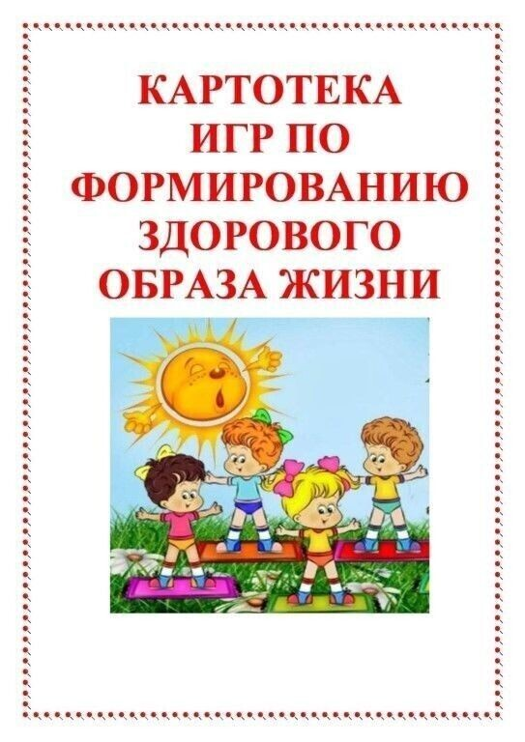](https://ok.ru/dk?cmd=PopLayerNewPhotoWrapper&st.layer.cmd=PopLayerNewPhotoOuter&st.layer.plc=mediaTopic&st.layer.photoId=924186322228&st.layer.type=GROUP&st.layer.sphotoIds=924186322228%3B924186322484%3B924186322740%3B924186322996%3B924186323252%3B924186323508%3B924186323764%3B924186324020&st.cmd=altGroupForum&st.groupId=57249006420020&st._aid=GroupTopicLayer_openPhotoLayer)

[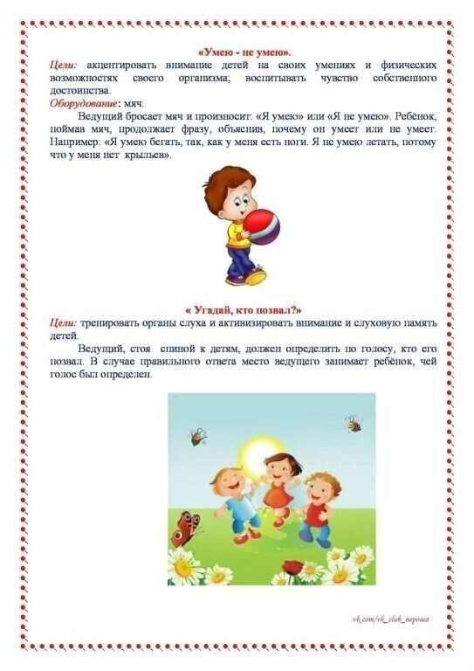](https://ok.ru/dk?cmd=PopLayerNewPhotoWrapper&st.layer.cmd=PopLayerNewPhotoOuter&st.layer.plc=mediaTopic&st.layer.photoId=924186322484&st.layer.type=GROUP&st.layer.sphotoIds=924186322228%3B924186322484%3B924186322740%3B924186322996%3B924186323252%3B924186323508%3B924186323764%3B924186324020&st.cmd=altGroupForum&st.groupId=57249006420020&st._aid=GroupTopicLayer_openPhotoLayer)

[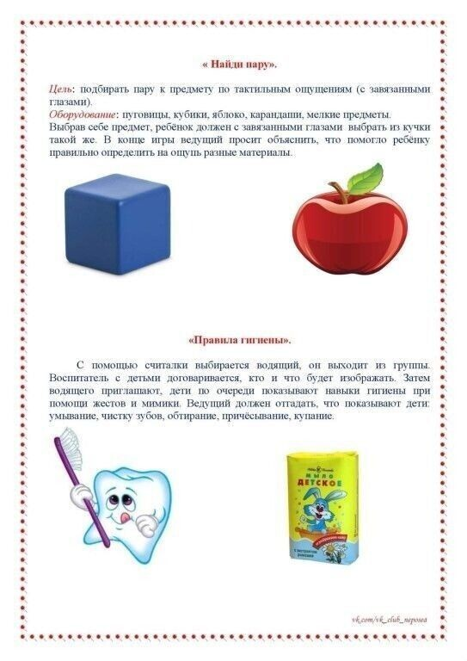](https://ok.ru/dk?cmd=PopLayerNewPhotoWrapper&st.layer.cmd=PopLayerNewPhotoOuter&st.layer.plc=mediaTopic&st.layer.photoId=924186322740&st.layer.type=GROUP&st.layer.sphotoIds=924186322228%3B924186322484%3B924186322740%3B924186322996%3B924186323252%3B924186323508%3B924186323764%3B924186324020&st.cmd=altGroupForum&st.groupId=57249006420020&st._aid=GroupTopicLayer_openPhotoLayer)

[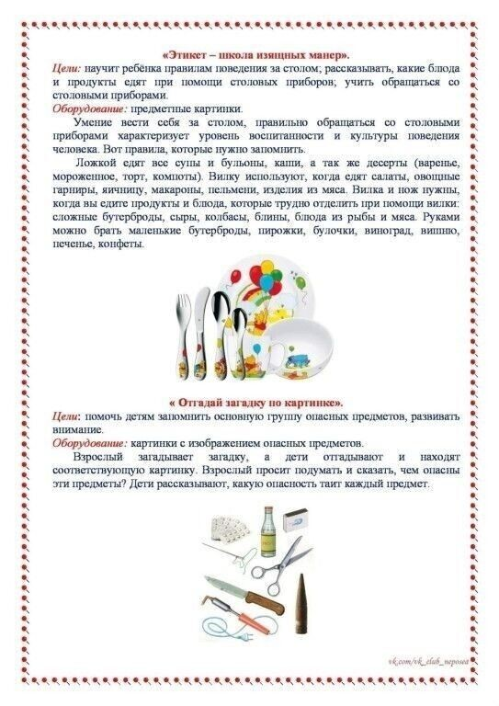](https://ok.ru/dk?cmd=PopLayerNewPhotoWrapper&st.layer.cmd=PopLayerNewPhotoOuter&st.layer.plc=mediaTopic&st.layer.photoId=924186322996&st.layer.type=GROUP&st.layer.sphotoIds=924186322228%3B924186322484%3B924186322740%3B924186322996%3B924186323252%3B924186323508%3B924186323764%3B924186324020&st.cmd=altGroupForum&st.groupId=57249006420020&st._aid=GroupTopicLayer_openPhotoLayer)

[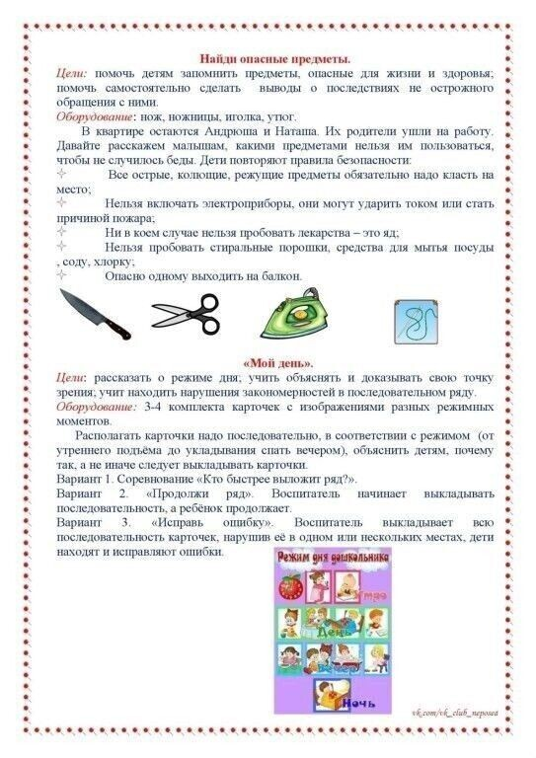](https://ok.ru/dk?cmd=PopLayerNewPhotoWrapper&st.layer.cmd=PopLayerNewPhotoOuter&st.layer.plc=mediaTopic&st.layer.photoId=924186323252&st.layer.type=GROUP&st.layer.sphotoIds=924186322228%3B924186322484%3B924186322740%3B924186322996%3B924186323252%3B924186323508%3B924186323764%3B924186324020&st.cmd=altGroupForum&st.groupId=57249006420020&st._aid=GroupTopicLayer_openPhotoLayer)

[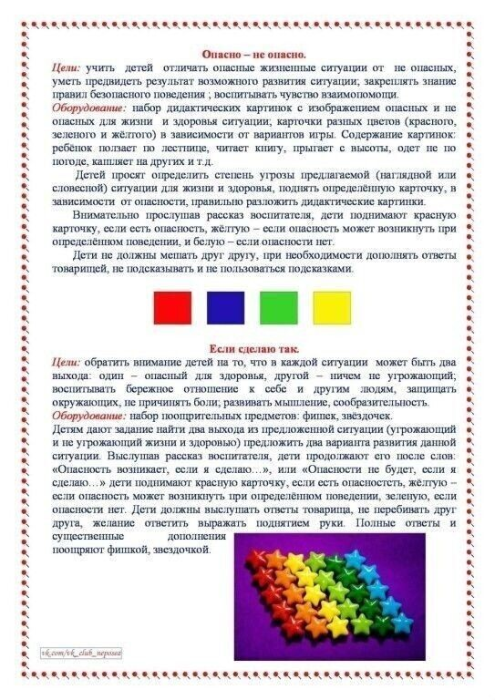](https://ok.ru/dk?cmd=PopLayerNewPhotoWrapper&st.layer.cmd=PopLayerNewPhotoOuter&st.layer.plc=mediaTopic&st.layer.photoId=924186323508&st.layer.type=GROUP&st.layer.sphotoIds=924186322228%3B924186322484%3B924186322740%3B924186322996%3B924186323252%3B924186323508%3B924186323764%3B924186324020&st.cmd=altGroupForum&st.groupId=57249006420020&st._aid=GroupTopicLayer_openPhotoLayer)

[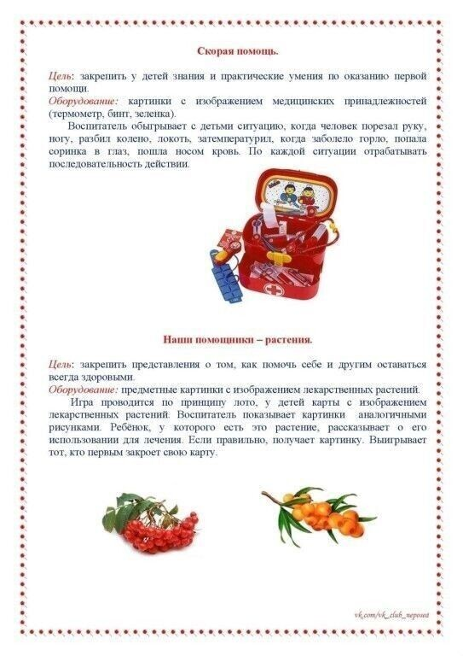](https://ok.ru/dk?cmd=PopLayerNewPhotoWrapper&st.layer.cmd=PopLayerNewPhotoOuter&st.layer.plc=mediaTopic&st.layer.photoId=924186323764&st.layer.type=GROUP&st.layer.sphotoIds=924186322228%3B924186322484%3B924186322740%3B924186322996%3B924186323252%3B924186323508%3B924186323764%3B924186324020&st.cmd=altGroupForum&st.groupId=57249006420020&st._aid=GroupTopicLayer_openPhotoLayer)

[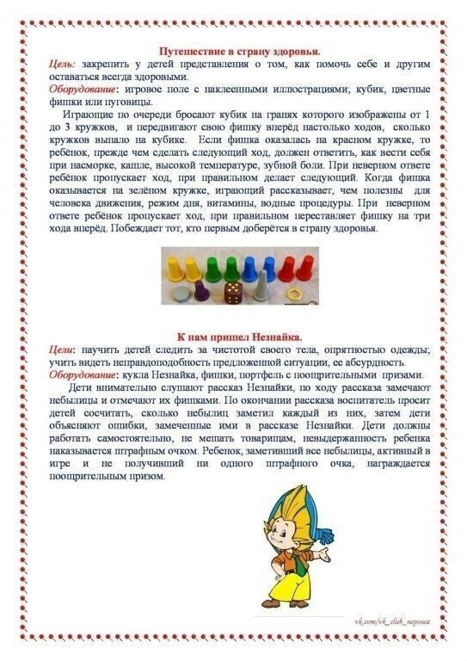](https://ok.ru/dk?cmd=PopLayerNewPhotoWrapper&st.layer.cmd=PopLayerNewPhotoOuter&st.layer.plc=mediaTopic&st.layer.photoId=924186324020&st.layer.type=GROUP&st.layer.sphotoIds=924186322228%3B924186322484%3B924186322740%3B924186322996%3B924186323252%3B924186323508%3B924186323764%3B924186324020&st.cmd=altGroupForum&st.groupId=57249006420020&st._aid=GroupTopicLayer_openPhotoLayer)